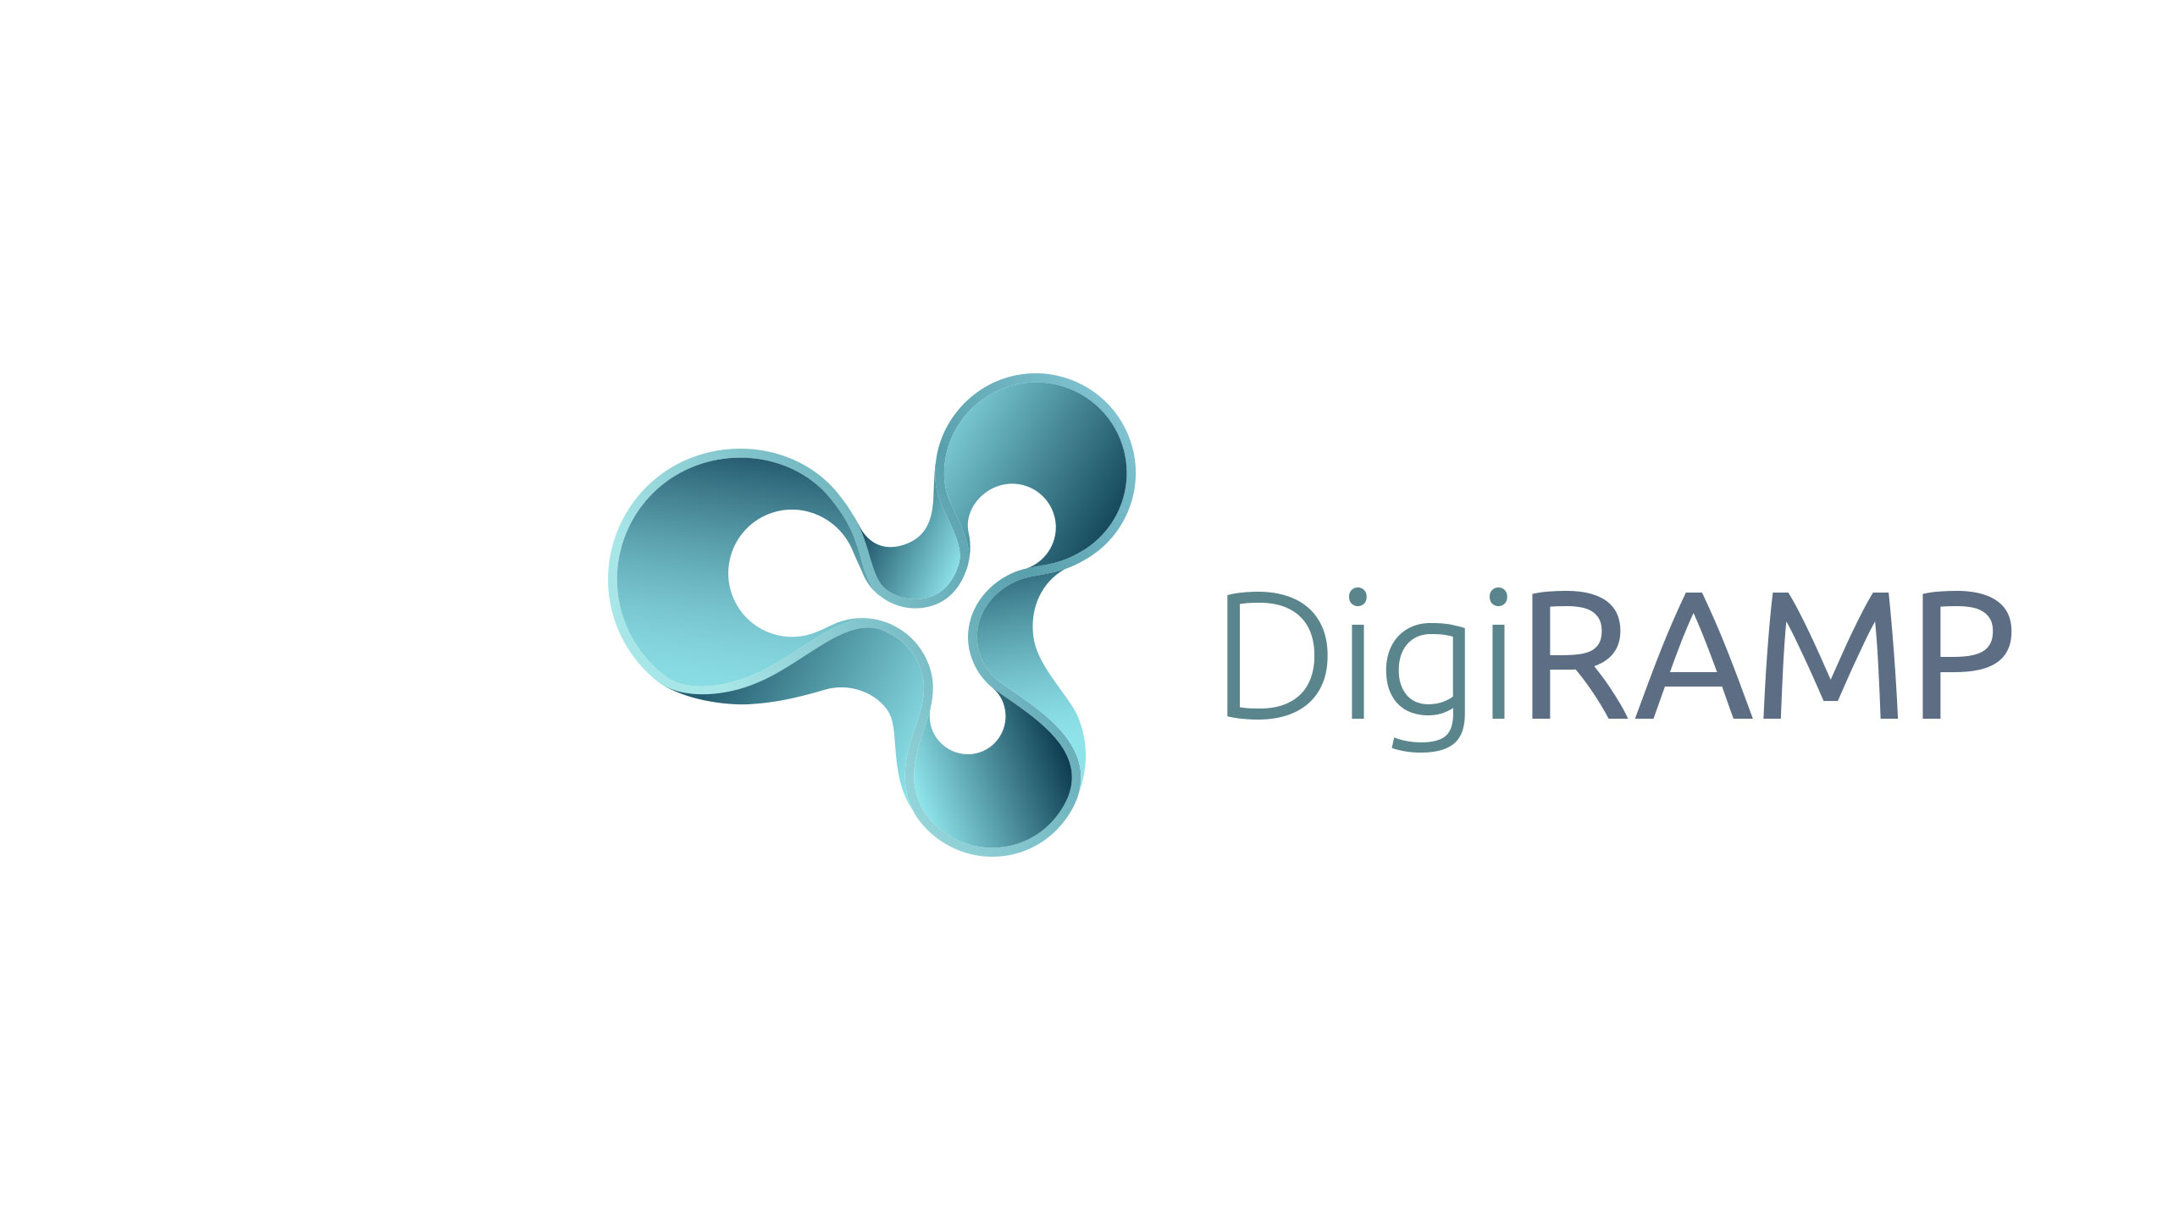
10713 Burbank Blvd. • North Hollywood CA 91601 • (818) 753-9300 t. • (818) 753-9966
DigiRAMP - A Simple Overview
A Content Delivery Network for Music
Integrates Rights and Media with Administration
Cut costs by Automation and Pays all stakeholders in real-time
Promotes Artists and Music content to industry and fans
Builds an audience with social network features
Every user gets their own marketplace with opportunities and tools to manage their own needs, to the benefit of all stakeholders
DigiRAMP takes a rake on all transactions
The list of revenue streams is long
• Shop / Curated products
• Streaming
• Licensing / Opportunities
• Metrics / Analytics
• Subscriptions
• Advertising
• Storage
• Email campaigns
• Publishing / Label / Administrating
• PRO / Collections
• Content delivery API / SDK / production library
• Bundling
• Plugins for DAW
• Services / Legal / Help to import / Special features / Education
• Books / Video
• DigiRAMP is an Aggregator
• Mobile apps
• Campaign tool
• Mastering
• Music Hardware
• Provide cleared music to hardware vendors, game developers and third party streaming app via an API

The music market as a whole is not shrinking. To the contrary, as the majors are losing their grip on the market share, the independent market is growing rapidly.

